**Itinerary for the 1000 meter test to be performed on Saturday, February 27th, 2016**

Formulated February 18, 2016 for use by the Engineering Mechanics and Space Systems Laboratory

North Carolina State University

Engineering Building III, Room 3406

# 1. Project overview

The tethered balloon system consists of a helium inflated balloon, a long tether, a gondola containing scientific instrumentation, and a wing subsystem. The final goal of the project is to experimentally determine if a tethered balloon system can be adequately controlled using a suspended wing subsystem. To determine the result of this project, a simulation will be constructed and used to predict the dynamics response of the system due to a given set of initial conditions and weather data. These predictions will then be compared to experiment to justify the results. Finally, the wing subsystem will be allowed to vary according to the output of a control algorithm in order to control the system. The first step towards the completion of this project is to perform tests on a moored balloon to validate a test case for the proposed dynamic model of the system. This test is outlined below.

# 2. Test day: Saturday, February 27th, 2016

The test will be conducted on Saturday, February 27th, 2016 at 181 Sunrise Farm Ln. Warrenton, NC 27589 (referred to hereafter as the Farm). As of 2/17/2016, the forecast for the day of the test is as follows:

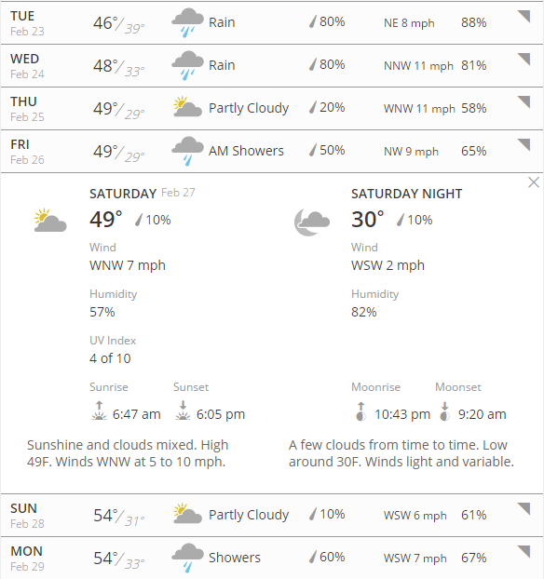

**Figure 1:** Forecast for Tuesday February 23th through Monday February 29th with emphasis on Saturday February 27th

If there is a chance of bad weather, the team will be notified no less than eight hours before the report time of the team of any modification of plans. Otherwise, it should be assumed that the plan will proceed as follows:

|  |  |  |
| --- | --- | --- |
| **Time** | **Location** | **Event** |
| 06:00 | EB3 3406 (Lab) | All team members are to report to the lab for pre-experiment briefing. Any questions regarding the events of the test will be addressed. Arrive to the lab early. |
| 06:30 | EB3 3406 (Lab) | Load transport vehicles with test items and supplies. |
|  |  |  |
| 06:45 | EB3 3406 (Lab) | Leave for the farm. |
| 08:30 | Farm | Arrive at the farm. |
| 08:45 | Farm | Unpack all test items. Keep all items together in one location for ease of access. All team members are to be made aware of the location of all tools, experiment parts, etc. |
| 09:00 | Farm | Assign tasks to team members for experimental procedure. Each team member is to be familiar with the procedure and any questions should be addressed at this time. |
| 09:15 | Farm | Begin following the experimental procedure for the balloon. |
| 09:30 | Farm | Flight of the 1000 foot test begins with the ascent with nodes |
| 13:00 | Farm | Flight of the 1000 foot test ends with the descent without nodes. |
| 13:15 | Farm | Deconstruct the experimental setup. Verify at least one tether node and the gondola data has been collected. |
| 13:45 | Farm | Pack the transport vehicles and prepare for departure from the field. |
| 14:00 | Farm | Leave for EB3 3406 (Lab). |
| 15:45 | EB3 3406 (Lab) | Arrive at EB3 3406 (Lab). |
| 15:50 | EB3 3406 (Lab) | Unpack transport vehicles. Return all test items and tools to the lab and store in their respective places. |
| 16:10 | EB3 3406 (Lab) | Post-experiment meeting of all team members involved in the experiment. Identify the pros and cons of the experiment, make suggestions for possible improvements to the next flight experiment, and leave feedback for use in experimental report writing. All documentation should be collected and stored from the test. |
| 16:30 | EB3 3406 (Lab) | Team members depart. |

# 3. Further information

Several things are worth reiterating for this test as these details are different from previous tests performed by the EMSSL.

1. The farm which will host us is doing this as a favor. Both the EMSSL and NC State University will be represented by the team while on the farm. Best behavior is required by all team members.
2. Bring old clothes which are able to get dirty. There is a chance the test will take place within a cow pasture. Please leave all nice clothes, shoes, and accessories either in a vehicle or at the lab before participating in the test.
3. The farm is approximately 90 minutes from NC State University (see the map below). All items required for the test need to be brought along for the journey. Those team members who are coming from a different location other than EMSSL will need to ensure arrival at the fam no later 08:30.

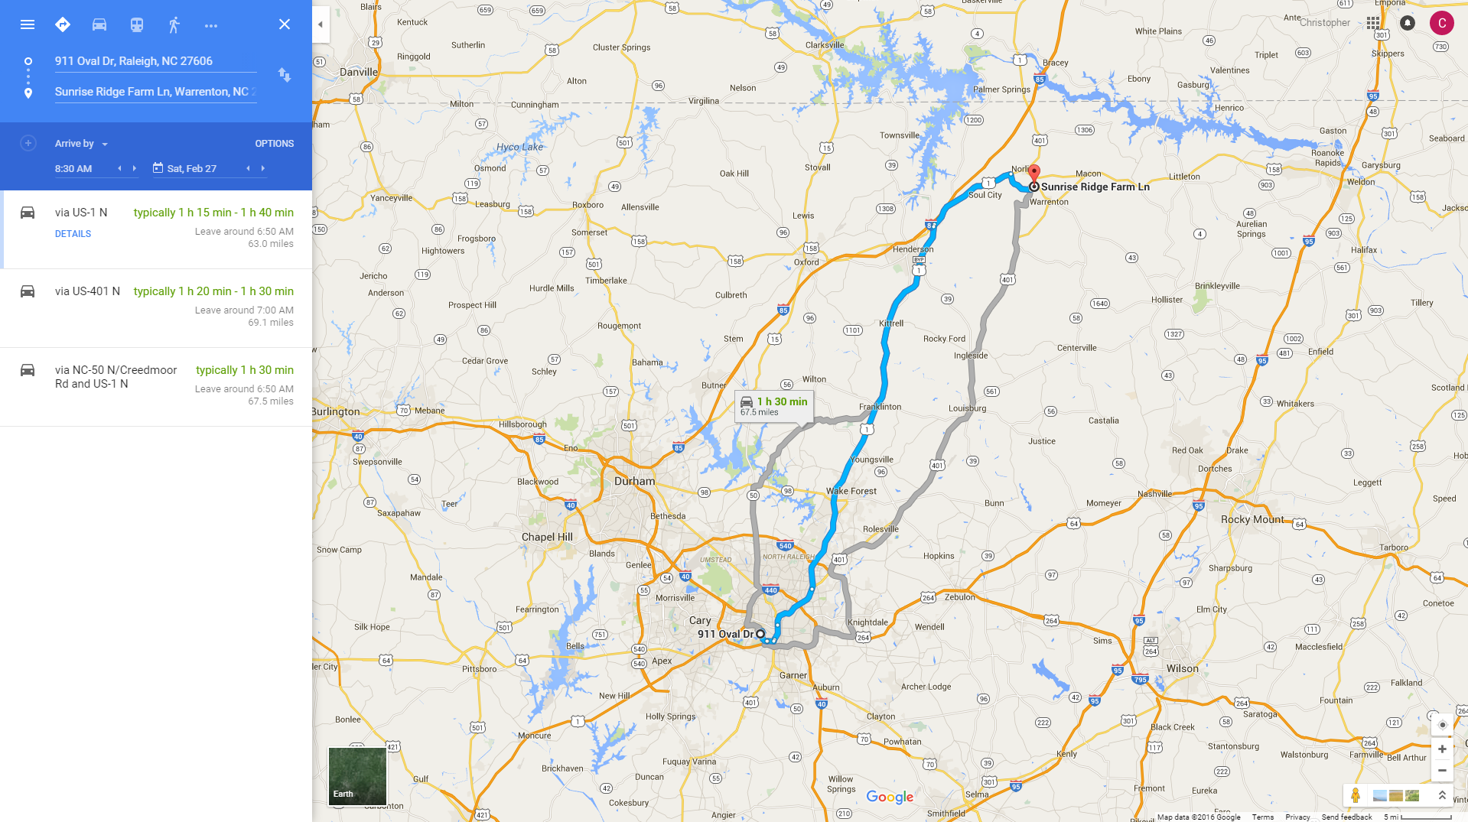

**Figure 2:** Map to the farm estimating the time of travel in order to arrive by 08:30 on February 27th, 2016

1. As per the itinerary, this test will be an all-day activity. If time constraints prohibit a team member from working all day, arrangements need to be made ahead of time for travel to/from the farm at the desired time.
2. Snacks/drinks are suggested for the team during the day. A pizza lunch will be arranged and delivered to the team at approximately lunch-time (time permitting and if the test is proceeding as planned). Doughnuts and coffee will be provided for the team in the morning and bottled water will be provided. Any additional beverages or food desired for the day needs to be provided by the team member.
3. As this test violates FAA regulations 101.13(a) and 101.17(b) (for further information, see the appendix section), the FAA has required that all persons participating in this test be thoroughly briefed on **a)** special field rules, **b)** manner and order of events, and **c)** special provisions of the CoW before beginning the activities. Furthermore, all team members must sign an official statement agreeing to being thoroughly briefed on special field rules, manner and order of events, and special provisions of the CoW. The last page of this itinerary is the statement. All team members **MUST** sign the last page of this itinerary, sign appropriately, and return the signed copy to Christopher D. Yoder before (or on) the morning of testing.

# Appendix A: List of waived regulations

These federal requlations may be found on e-CFR, the Electronic Code of Federal Regulations website published by the US Government Publishing Office. The specific subset of the regulations pertaining to this test may be found at: http://www.ecfr.gov/cgi-bin/text-idx?SID=da129fa6b7b7140a116cde3e0ab9a0f9&mc=true&tpl=/ecfrbrowse/Title14/14cfr101_main_02.tpl

Title 14, Chapter 1, Subchapter F, Part 101.13: Operating limitations

(a) Except as provided in paragraph (b) of this section, no person may operate a moored balloon or kite—

(1) Less than 500 feet from the base of any cloud;

(2) More than 500 feet above the surface of the earth;

(3) From an area where the ground visibility is less than three miles; or

(4) Within five miles of the boundary of any airport.

(b) Paragraph (a) of this section does not apply to the operation of a balloon or kite below the top of any structure and within 250 feet of it, if that shielded operation does not obscure any lighting on the structure.

Title 14, Chapter 1, Subchapter F, Part 101.17: Lighting and marking requirements.

(a) No person may operate a moored balloon or kite, between sunset and sunrise unless the balloon or kite, and its mooring lines, are lighted so as to give a visual warning equal to that required for obstructions to air navigation in the FAA publication “Obstruction Marking and Lighting”.

(b) No person may operate a moored balloon or kite between sunrise and sunset unless its mooring lines have colored pennants or streamers attached at not more than 50 foot intervals beginning at 150 feet above the surface of the earth and visible for at least one mile.

(Sec. 6(c), Department of Transportation Act (49 U.S.C. 1655(c)))

# STATEMENT OF BRIEFING

I, _________________________________, hereby state that I have been briefed fully of the conditions of the Certificate of Waiver (CoW) as granted to Christopher D. Yoder by the Greensboro FSDO on behalf of the Federal Aviation Administration for use in the 1000 meter test. I understand that the CoW may not be transferred to any other date and time outside of the granted dates and times, that the CoW grants permission to only waive federal restrictions as outlined in the CoW. I understand that misconduct which results in a violation of the terms and conditions of the CoW is grounds for cancelation of the test and possible legal action.

I understand that Christopher D. Yoder is providing a briefing to all team members regarding the test procedure and that it is my responsibility to attend this briefing. I understand that if I am unclear regarding an action, role, or procedure to be followed during the test, it is my responsibility to ask Christopher D. Yoder for clarification. I also agree to not participate in any activity which will jeopardize my safety, the safety of others, or place fellow teammates in a situation which violates the terms and conditions of the CoW.

Printed Name: _________________________________________________________________

Signature: _________________________________________________________________

Date: _________________________________________________________________